|  |  |  |  |
| --- | --- | --- | --- |
|  | Bansilal Ramnath Agarwal Charitable Trust's  Vishwakarma Institute of Information Technology  **Department of**  **Artificial Intelligence and Data Science** | | |
| Name: Siddhesh Dilip Khairnar | | | |
| Class: SY | Division: B | | Roll No: 272028 |
| Semester: IV | | Academic Year: 2022-2023 | |
| Subject Name & Code: Probability and Statistics: ES22201AD | | | |
| Title of Assignment: Binomial Distribution | | | |
| Date of Performance: 06-02-2023 | | Date of Submission: 13-02-2023 | |

**PAS Experiment No. – 3**

**Background information:**

The binomial distribution is a probability distribution that describes the number of successes in a fixed number of independent trials, each with the same probability of success.

The binomial distribution has two parameters:

1. The number of trials, denoted by "n"
2. The probability of success on each trial, denoted by "p"

The probability of getting exactly "k" successes in "n" independent trials with probability of success "p" is given by the following formula:

P (X = k) = (n choose k) * p^k * (1 - p)^(n - k)

where "n choose k" is the binomial coefficient, which can be calculated as:

(n choose k) = n! / (k! * (n - k)!)

where "!" denotes the factorial function.

In R, you can use the dbinom() function to calculate probabilities from the binomial distribution. The function takes three arguments:

1. The number of successes, denoted by "x"
2. The number of trials, denoted by "n"
3. The probability of success on each trial, denoted by "p"

**Program and Output:**

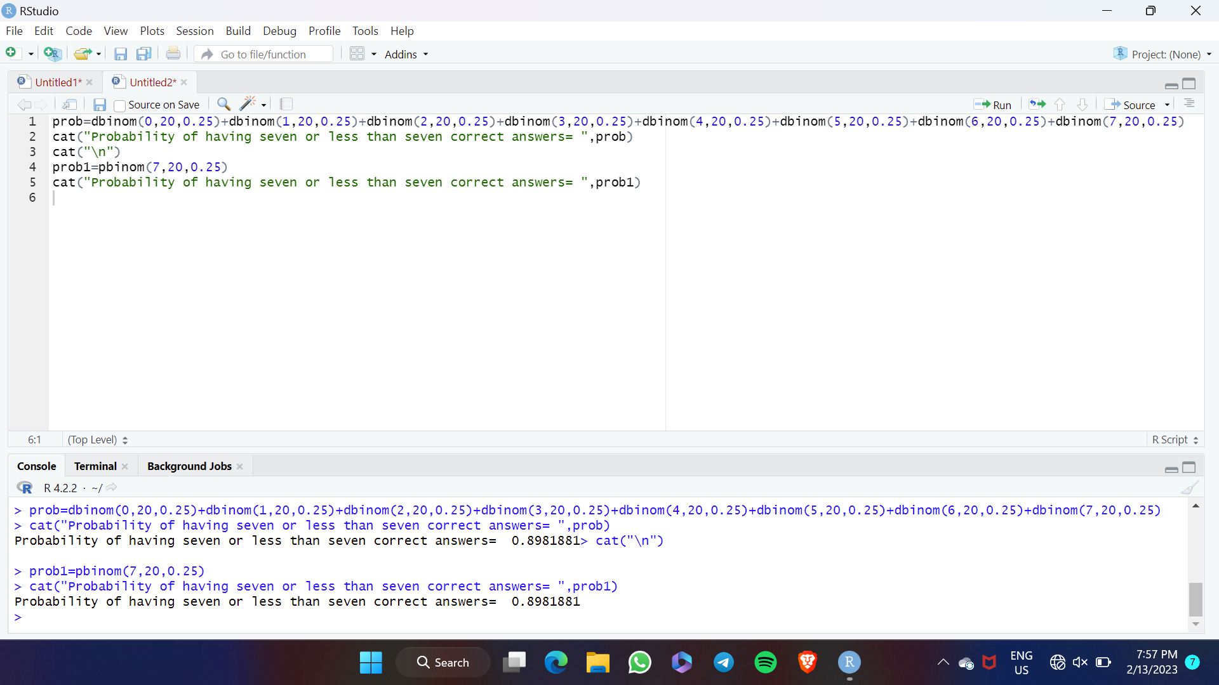

**Conclusion:** We successfully solve different problems regarding Binomial and Poisson Distribution on paper and in R studio also